Map pointing
RIVERS OF INDIA
- GANGA
- YAMUNA
- NARMADA
- TAPTI
- GODAVARI
- KRISHNA
- KAVERI
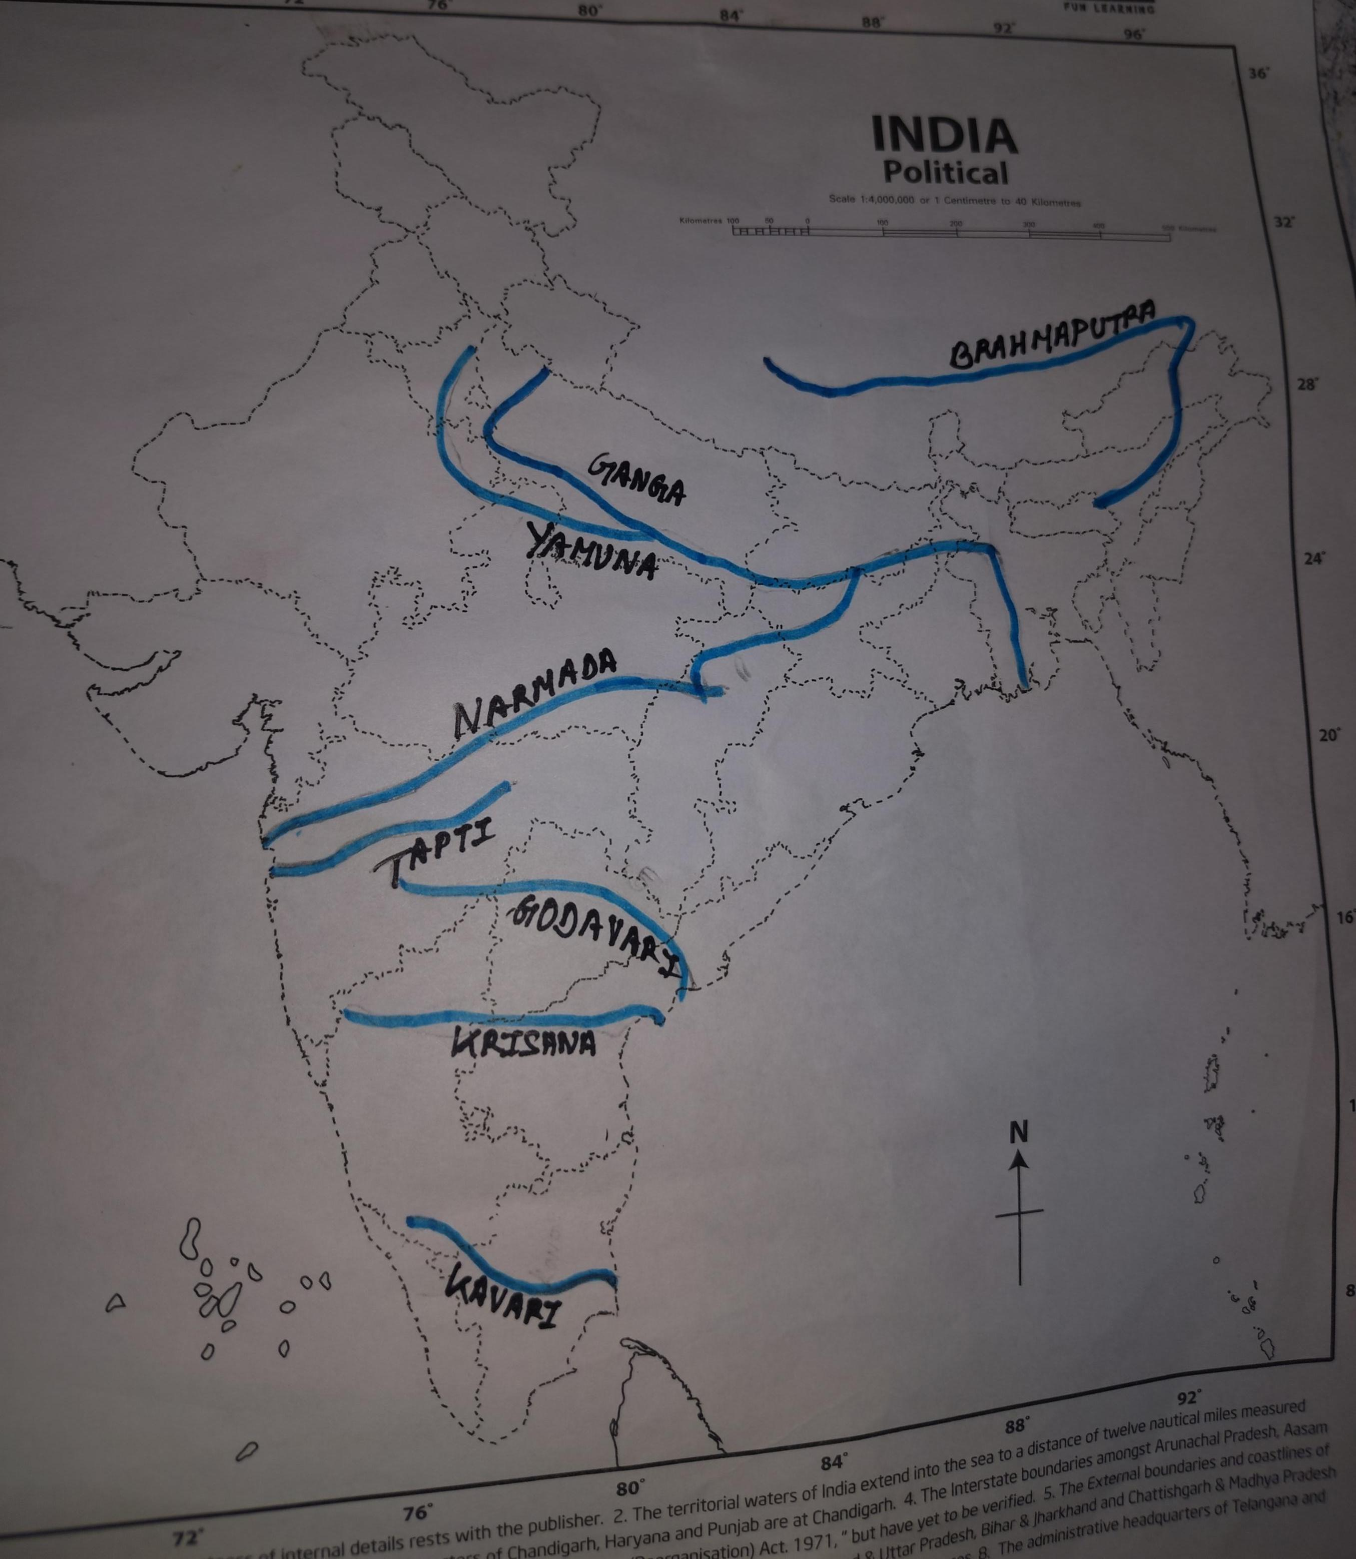
- BRAHMAPUTRA

